**Class Activity: Intent**

1. Pass my name!

In this activity, we will be making use of Intents with Extra. On the first activity page, the user will input their name. Upon clicking “Submit”, the data will be passed into the next activity page and display “Hello <name>! Hope you had a great day today!”.

First, create we will create two layouts, one with the editText component and “Submit” button. The other layout will have a TextView which we will update later.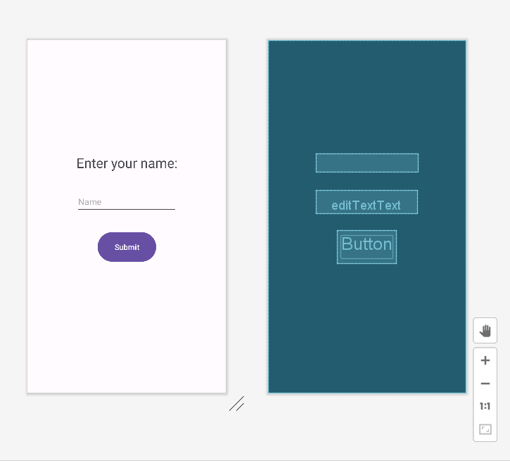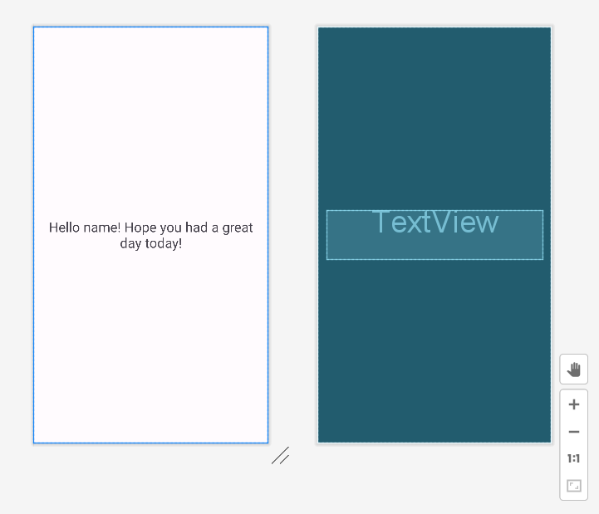

In the first main activity, get the input of the user’s name after submitting and pass it into an Intent object, making use of Extra. Start a new activity, main activity 2, passing the intent and retrieving the name to be displayed in the TextView.

When creating the new activity, remember to add these details/ make these changes into the files:

Link the associated activity in your xml layout:

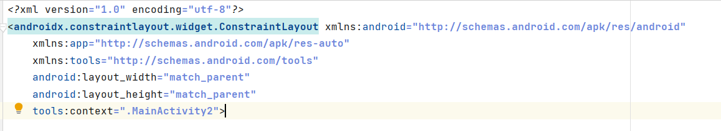

In your new main activity class, correctly link the layout:

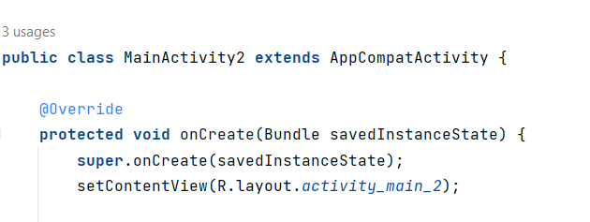

Add the new activity page created into your “AndriodManifest.xml” file:

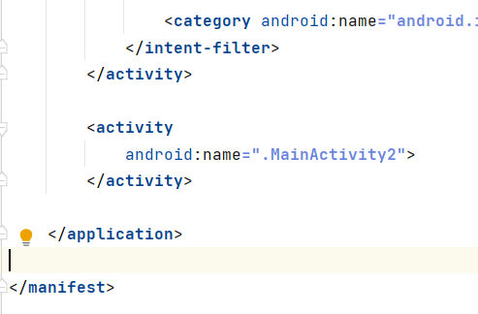

**Expected output:**

